# Infrared signal receiver

## Infrared remote control and infrared receiving module:

Infrared remote control: It is a good wireless communication method. It is used more often for some electrical equipment at home, such as TV, air conditioner, fan, etc. As long as you press the button of infrared remote control, the electrical equipment will turn on the corresponding functions, which is very convenient to use.

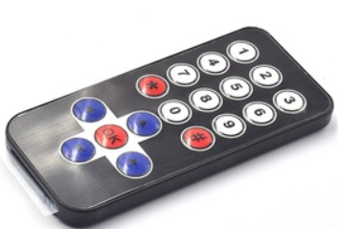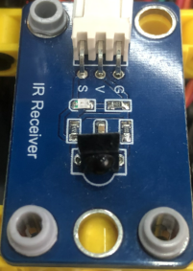

Infrared receiving module: used to receive data sent by infrared remote control.

## Install the infrared signal receiver

|  |  |
| --- | --- |
| Remove the red part of the picture below from the music percussion instrument of the last lesson  拆下音乐打击器红色部分 | The remaining structure is shown in the following figure  拆完后 |
| 红外信号接收器_空白视图 7 | 红外信号接收器_空白视图 7_1 |
| 红外信号接收器_空白视图 7_2 | 红外信号接收器_空白视图 7_3 |
| 红外信号接收器_空白视图 7_4 | 红外信号接收器_空白视图 7_5 |
| 红外信号接收器_空白视图 7_6 | 红外信号接收器_空白视图 7_7 |
| 红外信号接收器_空白视图 7_8 | 红外信号接收器_空白视图 7_9 |
| 红外信号接收器_空白视图 7_10 | 红外信号接收器_空白视图 7_11 |
| 红外信号接收器_空白视图 7_12 | 红外信号接收器_空白视图 7_13 |
| 红外信号接收器_空白视图 7_14 |  |
| Wiring diagram | |

### Read the signal values of the infrared remote control

**（1）Add infrared receiving plug-in**

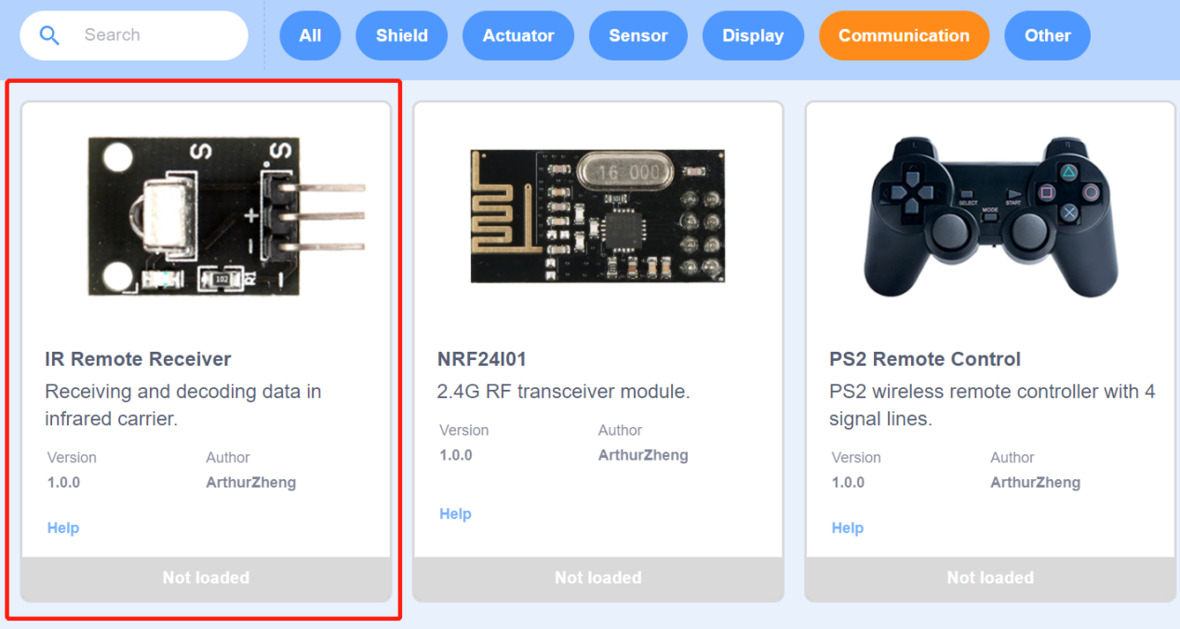

1. **Program block**

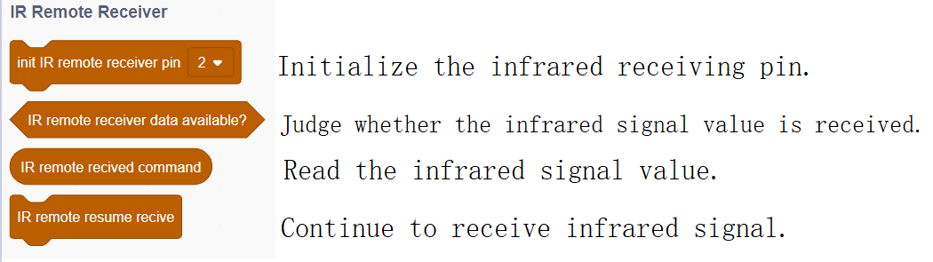

1. **Example program**

|  |
| --- |
|  |

**（4）Experiment phenomenon**

Use the infrared remote control to aim at the infrared receiving module of BENGBENG, press the remote control button, and the serial port monitor of SnailBlock will print the received infrared signal values.

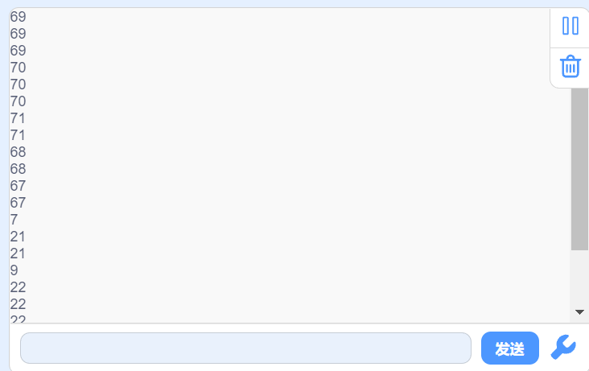

**（5）Infrared remote control button values diagram**

The values of the infrared remote controller are printed in the serial port monitor. Now we make a graph of the values for easy viewing.

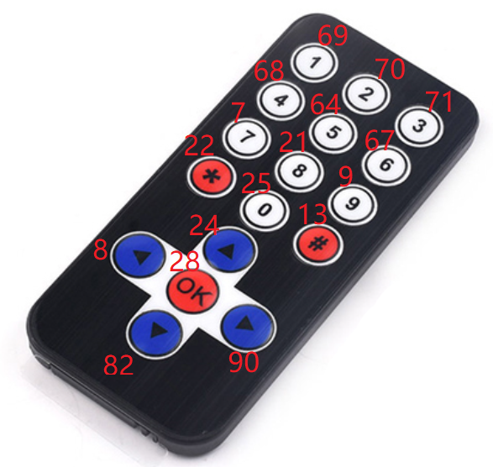

### The remote control turns on the light

Use button 1 to control the LED light on, and button 2 to control the LED light off.

1. Example program

|  |
| --- |
|  |

（2）Experiment phenomenon

When the infrared remote control is aimed at the infrared receiving module of BENGBENG, press button 1, and the LED light will be on. Press button 2, and the LED light will be off.

### Infrared remote control music performance

There are many buttons on the infrared remote control. We can set the buttons to control the buzzer to emit different tones, and then we can use the infrared remote control to play simple music.

（1）Example program

|  |
| --- |
|  |

1. **Experiment operation and phenomenon**

Click the infrared buttons according to the number below.

1 1 5 5 6 6 5 4 4 3 3 2 2 1

do do so so la la so fa fa mi mi re re do